**Property Site Visit Photo**

1. **Property Information:**

|  |  |  |  |  |  |  |  |  |  |
| --- | --- | --- | --- | --- | --- | --- | --- | --- | --- |
| **Property Information** | | | | | | | | | |
| Property Type | : A parcel of land erected upon with a single-storey terraced house | | | Land Area | | | | : 74 sqm | |
| Property Address | : Phum Trapaing Lvea, Sangkat Kakab, Khan Por Senchey, PP | | | Estimated Building Area | | | | : 64 sqm | |
| Formal VR | : N/A | | | Date | | | | : N/A | |
| **Security Value** | **Valuation Report** | | | **Indicative Value** | | | | | |
| Land Value | : N/A | | | : USD45,000 (USD600/sqm) | | | | | |
| Building Value | : N/A | | | : USD14,000 (USD250/sqm) | | | | | |
| **OMV** | **: N/A** | | | **: USD59,000** | | | | | |
| Valuer(s) | : N/A | | | : ARC | | | | | |
| **Security Value** | **: N/A** | | | **FSV** | | | **: N/A** | | |
| **Existing Insurance** | [ ] Yes | [ ✓ ] No | **Insurer** | **: N/A** | | | | | |
| **Encumbrance** | [ ] Yes | [ ✓ ] No | **Bank Name** | **: N/A** | | | **Limit: N/A** | | |
| **Property Conditions and Adverse Impacts on Market Value** | | | | | | | | | |
| Occupancy rate of neighboring property | | | | | [ ] Poor | [ ] Fair | | | [ ✓] Good |
| Demand for sale/rent | | | | | [ ] Poor | [ ] Fair | | | [ ✓] Good |
| Incidence of crime on vicinity | | | | | [ ✓] Low | [ ] Average | | | [ ] High |
| Road accessibility to the property over 6m | | | | | [ ✓] Yes | [ ] No | | |  |
| Is the property located in flood area | | | | | [ ] Yes | [ ✓] No | | |  |
| Is the property located near loathsome facilities (ref: page 18 of CPG) | | | | | [ ] Yes | [ ✓] No | | |  |
| The property is found to be in good state of repair | | | | | [ ✓] Yes | [ ] No | | |  |
| *If No, please comment:* | | | | |  |  | | |  |
| **Brief on the property and surrounding area** | | | | | | | | | |
| Subject property is Eo Flat with roof located in favorable zone, about 1Km from Porchen Tong Market. The property is surrounded by markets, hospitals, schools, residences, and many business’s activities. (Max. LTV is 70%) | | | | | | | | | |

1. 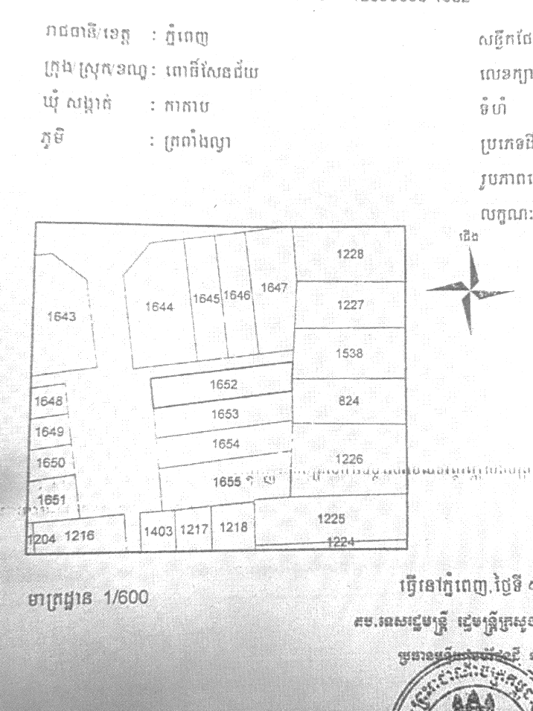**Land Shape:**

1. **Location:**

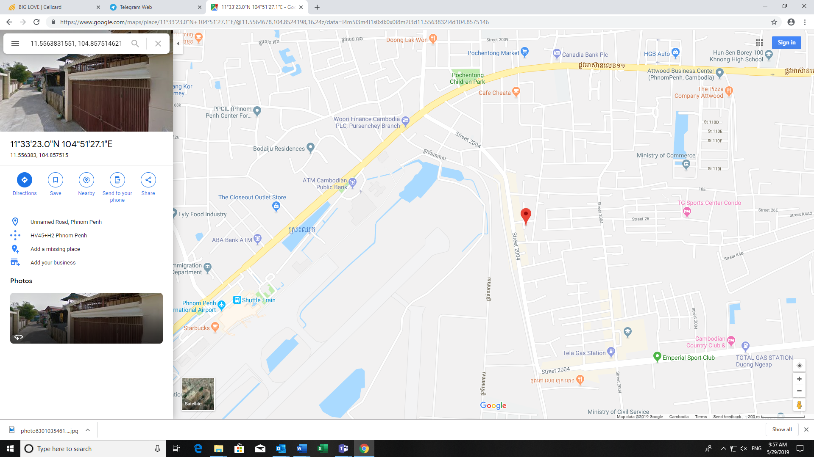

Subject Property

International Phnom Penh Airport

Porchen Tong Market

Cambodian Country Club (CCC) St. 2004

Cencury Plaza Market

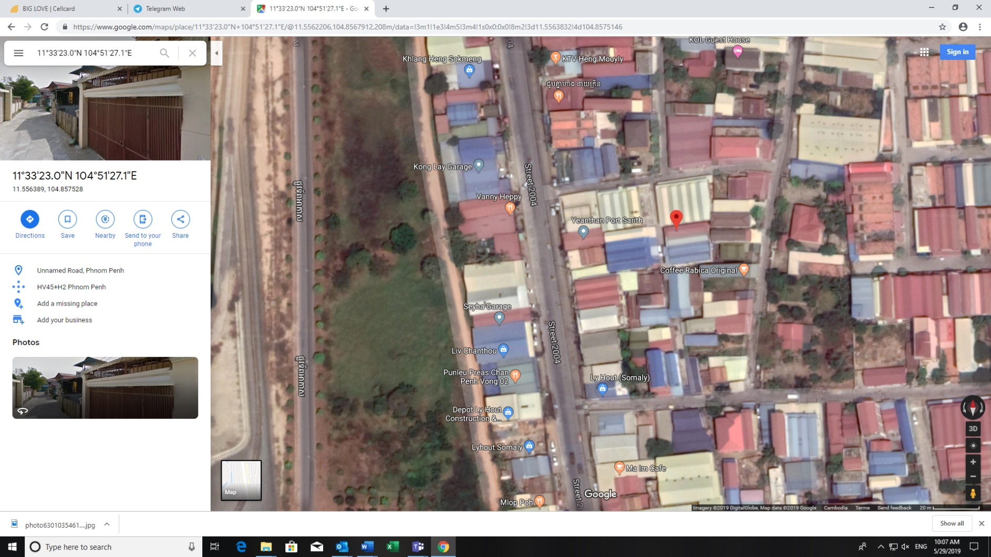

**Subject Property**

International Phnom Penh Airport

1. **Property Photo: (Collateral)**

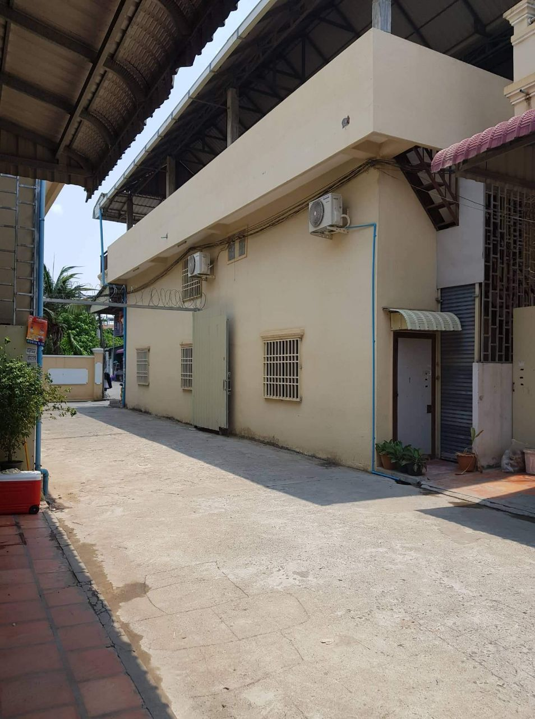

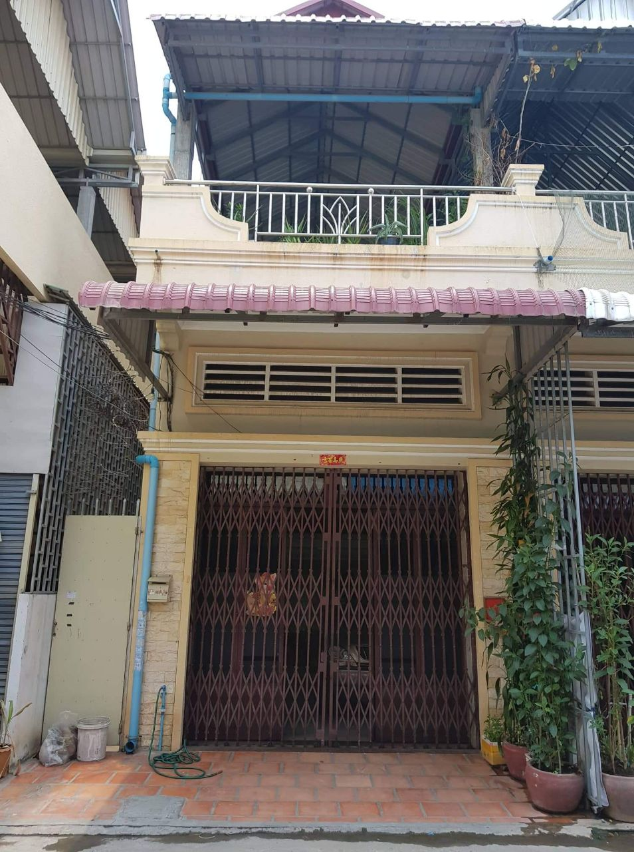

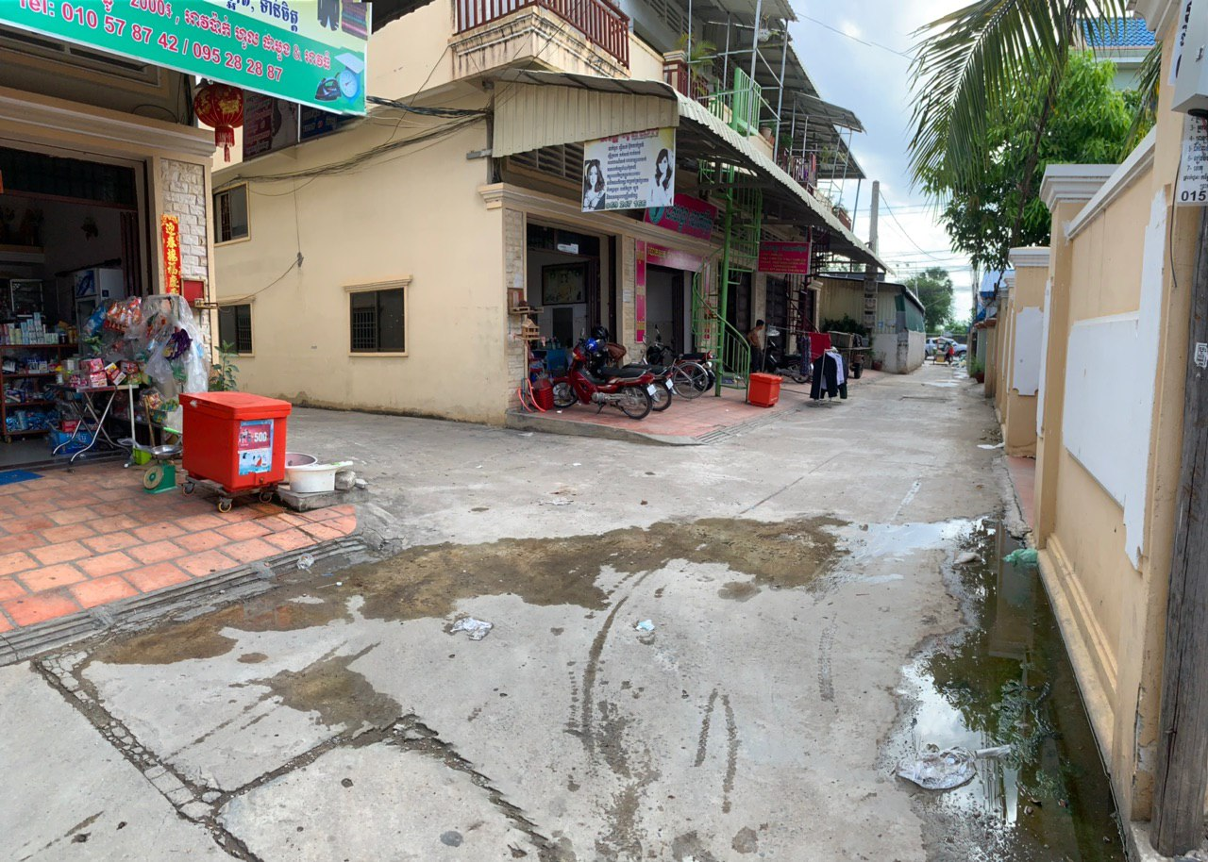

**Surrounding area**

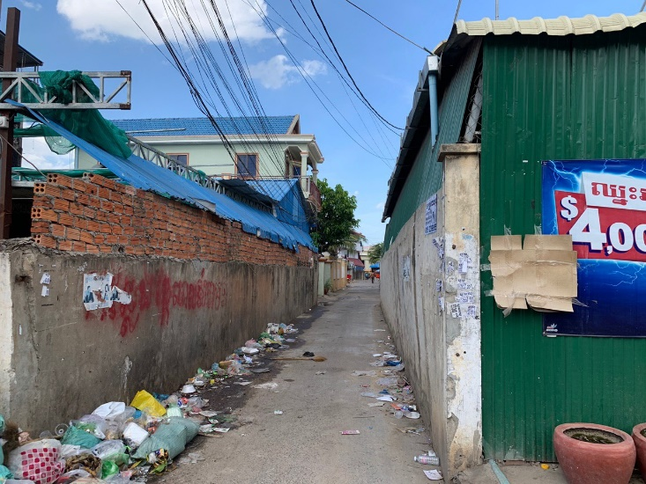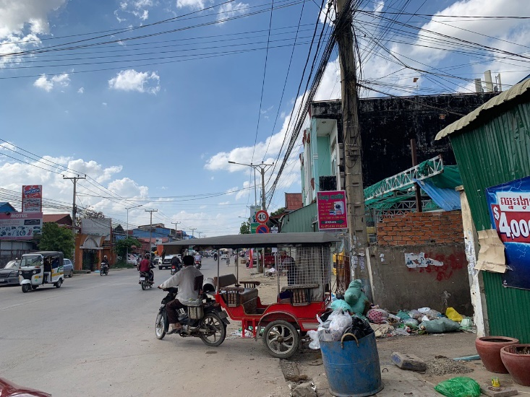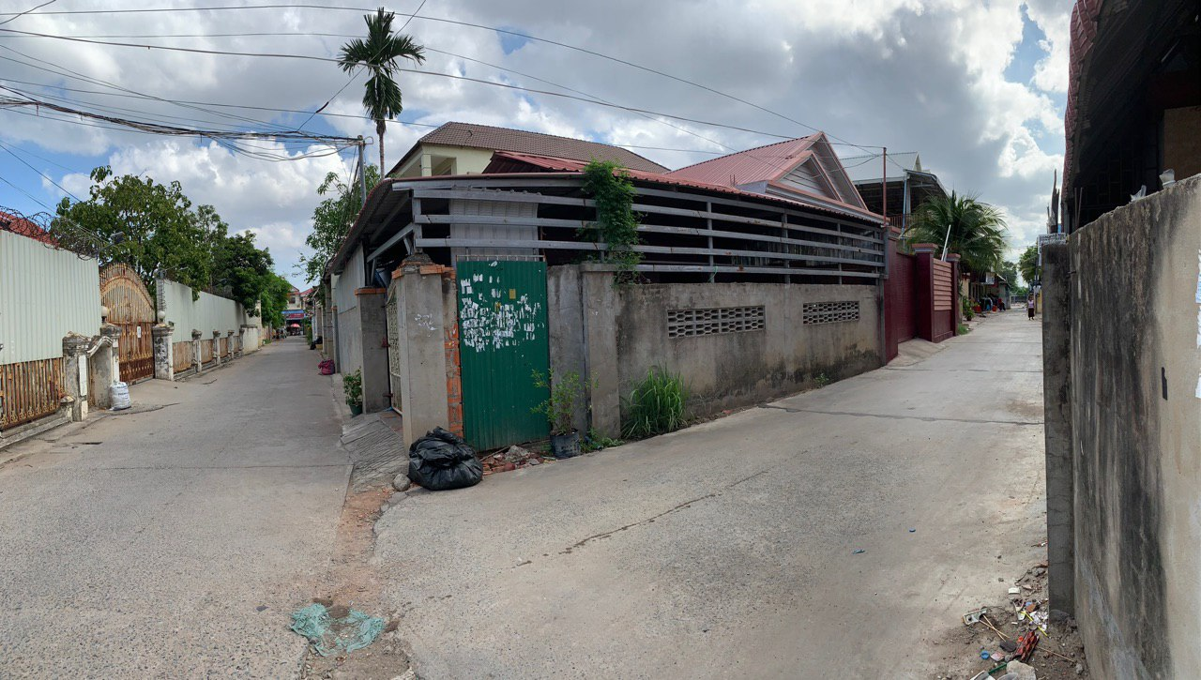

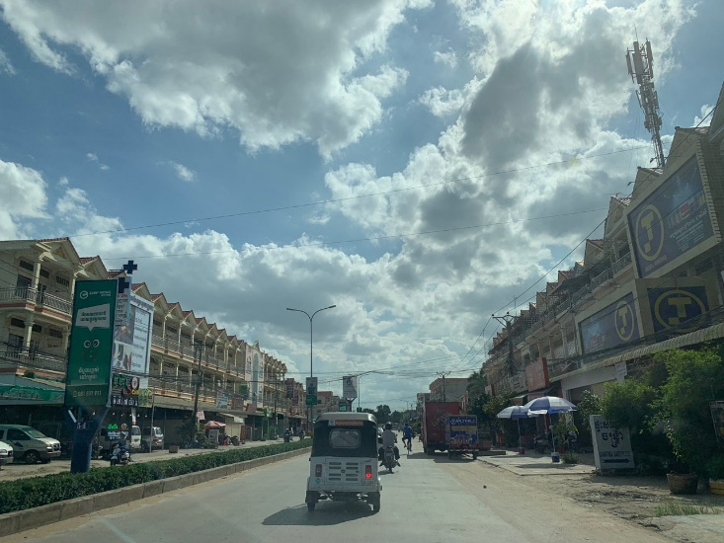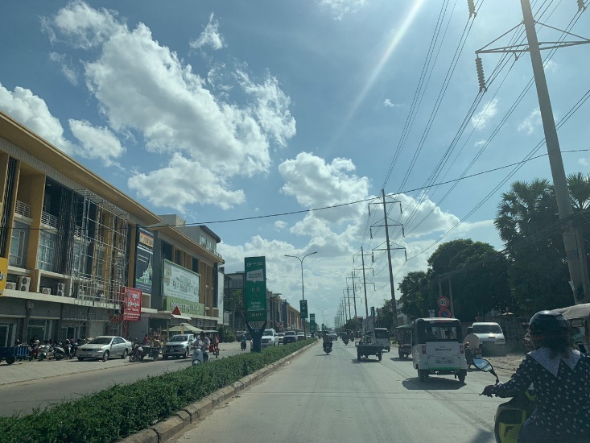

**The purchased Eo Flat (Borey Piphum Thmey – Chamkar Doung)**

